
APPLICATION
DEVELOPMENT THEORY 4
Technical Report on Software Dependability and Security
Term 4 Assignment 4

Group Members:

No. | Surname and Name | Student Number
1 | Kabai Moipone | 2 | 1 | 5 | 2 | 0 | 3 | 5 | 6 | 9
2 | Msomi Sebe | 2 | 1 | 6 | 0 | 2 | 8 | 6 | 0 | 4

Due Date: 21 October 2020
Table of Contents

Background overview 3

Introduction 3

Software Dependability plan 4-6
Figure 1 - Dependability properties 4
Availability 4-5
Reliability 5-6
Figure 2 – Error message for login 6
Safety 6

System Security plan 6-7
Three main types of security threats 7
Controls to enhance system security 7

Conclusion 8

Reference 8

Background overview
During the COVID-19 Lockdown periods in South Africa several companies experienced security problems as there has been several security incidents and breaches. These ranged from webpages freezing, systems crashes, identity theft and fraud. This was caused by security issues that were never secured enough to avoid such incidents from happening. Having seen these issues occur and happen, we propose to develop an application for Cape Town tourists called TourSpace that will be secure, reliable, and safe using the Software dependability and System security plans.
Introduction
As computer systems have become deeply embedded in our business and personal lives, the problems that result from system and software failure are increasing. A failure of server software in an e-commerce company could lead to a major loss of revenue, and possibly also customers for that company.
The most significant challenge that we face in software engineering is ensuring that we can trust these systems. To trust a system, we must have confidence that it will be available when required and perform as expected. It must be secure so that our computers or data are not threatened by it. This means that issues of system dependability and security are often more important than the details of system functionality. As computer systems have become deeply embedded in our business and personal lives, the problems that result from system and software failure are increasing. A failure of server software in an e-commerce company could lead to a major loss of revenue, and possibly also customers for that company.
TourSpace will be an application that will be secure and always available, and reliable for our customers to use at all times. We will make sure no issues arise in this application by using the suitable methods and right software development principles. This system that will provide the desired level of software dependability and system security.

Software Dependability plan
(Dependability, 2020) states that in systems engineering, dependability is a measure of a system's availability, reliability, and its maintainability, and maintenance support performance, and, in some cases, other characteristics such as durability, safety and security. The TourSpace system will cater all the software dependability elements such as availability, reliability and safety.
To ensure we are confident in our TourSpace system during the COVID-19 lockdown periods, we will develop a dependable software. To unsure that we avoid accidental errors in the system during software specification and development, we will design verification and validation processes to effectively discover errors that may affect the dependability of the system, and protect the system from external attacks that can compromise the availability or security of the system.
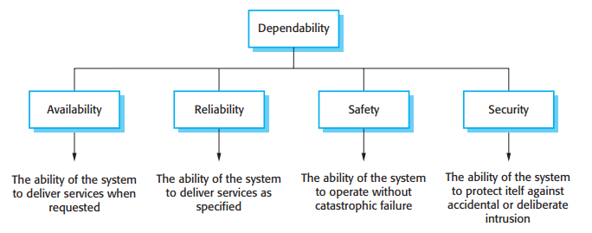Figure 1 - Dependability properties
- Availability of TourSpace system is that the system will deliver services as requested. It will be up and running and able to deliver useful services to the user at any given time. For example, the amount of time the system is operating as the percentage of total time it should be operating. This system’s availability will report availability in terms of minutes or hours of downtime per month. The system will stay operational even when faults occur and continue operating at a reduced capacity. Since availability of a system is given as a percentage of the time a system is expected to be available, TourSpace will be available 99.999% (“five nines”) per month. The TourSpace will be available whenever a demand is made. The measures for our system to be available: the system is not out of service for repairs or inspections, it is functioning under normal conditions at an expected rate and functioning when needed at any time. To assess our system availability, we will calculate the availability by dividing uptime by the total sum of uptime and downtime. We will do a system availability analysis so that we could explore many or new ways to decrease downtime and make it operate more efficiently and effectively. We will consider maintainability at this stage as well to ensure new requirements emerge.
- Reliability is the ability of the system to deliver services as specified. The reliability of the system is the probability, over a given period, that the system will correctly deliver services as expected by the user.
  - Reliability of our system: The TourSpace system is guaranteed to be reliable. All inputs to the system will be selected from the options that will be provided by the system. Since the system will only provide valid options, there is absolutely no possibility of invalid inputs from the user. The user will not be provided options to type or provide information except when they log in. Each user will have a unique username and password. This removes the risk of unauthorized access to the system. Customers need a legitimate login details to accurately access TourSpace system. This will ensure reliability of the system. We will consider the complimentary approaches to improve the reliability of TourSpace system. This system will be fault avoidance such that human errors will be minimized in a sense that customers will not be given option to type except when they log in. The system will use verification and validation techniques to test if the functionality works as required. TourSpace will not be fault tolerant to ensure that faults do not result in system errors or failures. The TourSpace system will deliver all the requirements as defined in the system specification. For a good example of reliability to our TourSpace is having it running every time we log in.
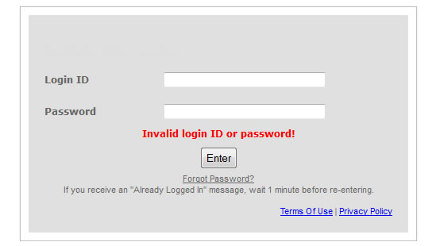
Figure 2 – Error message for login
- Safety of TourSpace system is that the system will not cause damage to people even in cases of its failure. Since this is not a critical system, it will be safe to use. We will ensure that accidents do not occur or that are minimal by making sure that the system is designed in such way that hazards are detected and removed before they result in an accident. For example, we will ensure that the system is protected against and designed to handle unexpected software behavior.
System Security plan
According to Summerville (2011:302), security is a system attribute that reflects the ability of the system to protect itself from external attacks, which may be accidental or deliberate. These external attacks are possible because most general-purpose computers are now networked and are therefore accessible by outsiders. Examples of attacks might be the installation of viruses and Trojan horses, unauthorized use of system services or unauthorized modification of a system or its data.
For some systems, security is the most important dimension of system dependability. Military systems, systems for electronic commerce, and systems that involve the processing and interchange of confidential information like our TourSpace system must be designed so that they achieve a high level of security. For example, if a hotel reservation system is unavailable, this causes inconvenience and some delays in issuing the room confirmation reference. However, if the system is insecure then an attacker could delete all bookings and it would be practically impossible for normal hotel operations to continue.
In any networked system, the following are the three main types of security threats:
- Threats to the confidentiality of the system and its data: These can disclose information to people or programs that are not authorized to have access to that information.
- Threats to the integrity of the system and its data: These threats can damage or corrupt the software or its data.
- Threats to the availability of the system and its data: These threats can restrict access to the software or its data for authorized users.
These threats are interdependent. If an attack makes the system unavailable, then the system will not be able to update information that changes with time. This means that the integrity of the system may be compromised. If an attack succeeds and the integrity of the system is compromised, then it may have to be taken down to repair the problem. Therefore, the availability of the system is reduced.
The controls to be put in place to enhance TourSpace system security:
- Vulnerability avoidance: Controls that are intended to ensure that attacks are unsuccessful. The strategy here is to design the system so that security problems are avoided. For example, sensitive TourSpace systems will not be connected to public networks so that external access is impossible. Encryption will also be good as a control based on avoidance. Any unauthorized access to encrypted data means that it cannot be read by the attacker.
- Attack detection and neutralization: Controls that are intended to detect and repel attacks. These controls will involve functionality in a system that monitors its operation and checks for unusual patterns of activity. If they are detected, then action may be taken, such as shutting down parts of the system, restricting access to certain users, etc.
- Exposure limitation and recovery: Controls that support recovery from problems. These can range from automated backup strategies and information ‘mirroring’ to insurance policies that cover the costs associated with a successful attack on the system.

Conclusion
In conclusion, without a reasonable level of security, we cannot be confident in a system’s availability, reliability, and safety. Methods for certifying availability, reliability, and security assume that the operational software is the same as the software that was originally installed. If the system has been attacked and the software has been compromised in some, then the reliability and safety arguments no longer hold. Summerville (2011:305) says errors in the development of a system can lead to security loopholes. If a system does not respond to unexpected inputs or if array bounds are not checked, then attackers can exploit these weaknesses to gain access to the system. Major security incidents took advantage of the same vulnerability. Programs in some programming languages do not include array bound checking, so it is possible to overwrite part of memory with code that allows unauthorized access to the system, resulting in many systems to be unsecure.

Reference
- IEC, Electropedia del 192 Dependability, http://www.electropedia.org, select 192 Dependability, see 192-01-22 Dependability.
- Presentations.akamaized.net. 2020. VTS Troubleshooting Documents | Login Problems | Invalid Password. https://presentations.akamaized.net/Help/VTS/LoginProblems/invalidpassword.html [5 November 2020].
- Summerville, I. 2011. Software Engineering. 9th ed. Boston. Pearson.

